Specific learning objectives
- To enumerate four main groups of lymph nodes along with direction of lymph flow draining the stomach

Lymphatic drainage of stomach

Untitled Accordion
Classical view of lymphatic drainage
[TIP]Most of the lymphatic drainage of the stomach finds its way to the celiac nodes
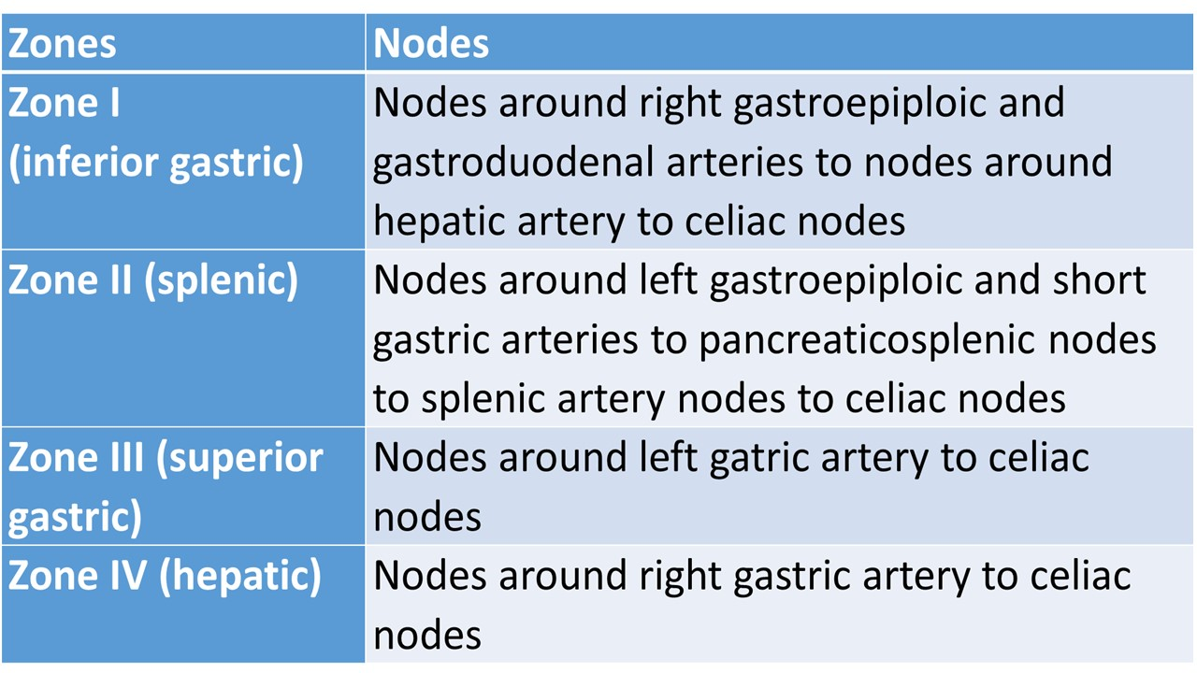

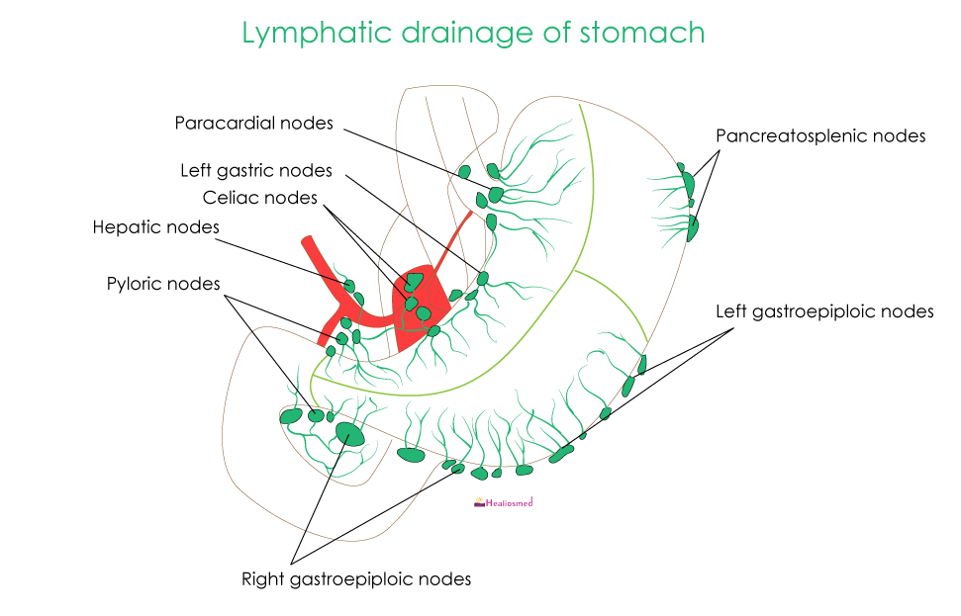





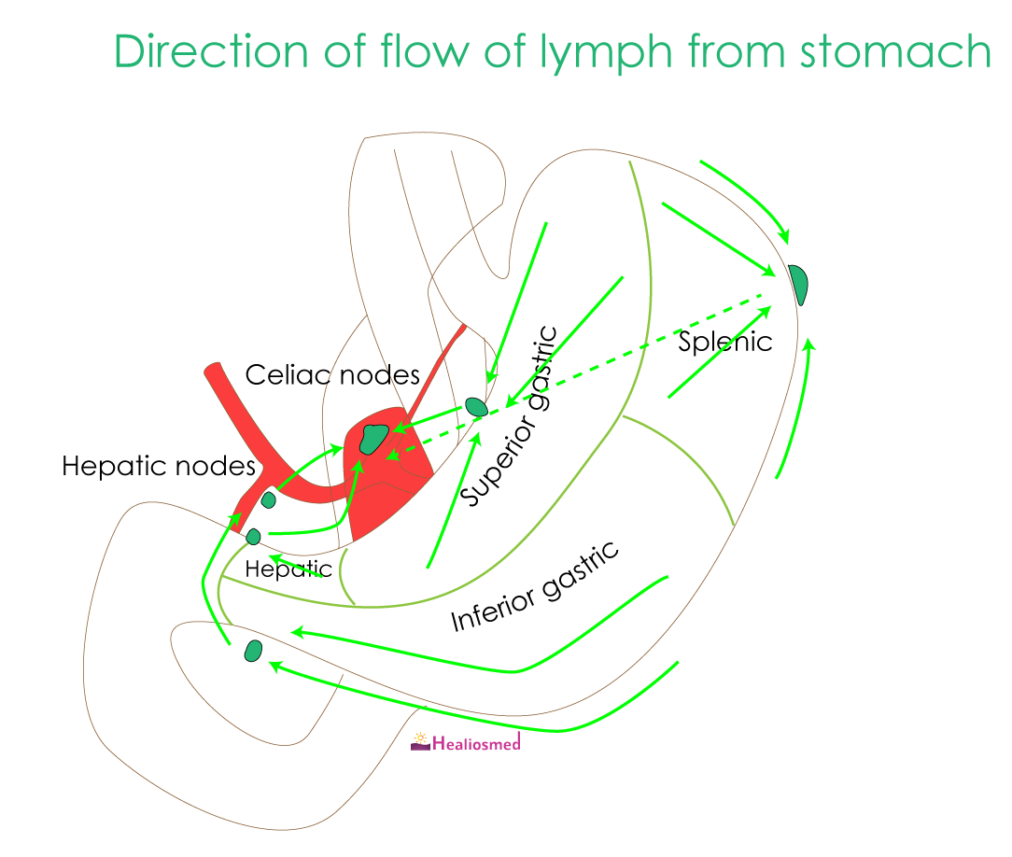


Metastasis
Lymphatic drainage follows the arteries of the stomach or parallels gastric venous return; metastases are not confined to the nodes draining a single zone

Direction of lymph drainage
Arrows indicate that most of the drainage finds its way to the celiac nodes
Zone I (inferior gastric) drains into the subpyloric and omental nodes
Zone II (splenic) drains into the pancreaticosplenic nodes
Zone III (superior gastric) drains into the superior gastric nodes
Zone IV (hepatic) drains into the suprapyloric nodes

Lymphatic drainage of the stomach and nodal stations according to the Japanese classification
Japanese Research Society for Gastric Cancer has assigned a number to each lymph node station to aid the pathological staging

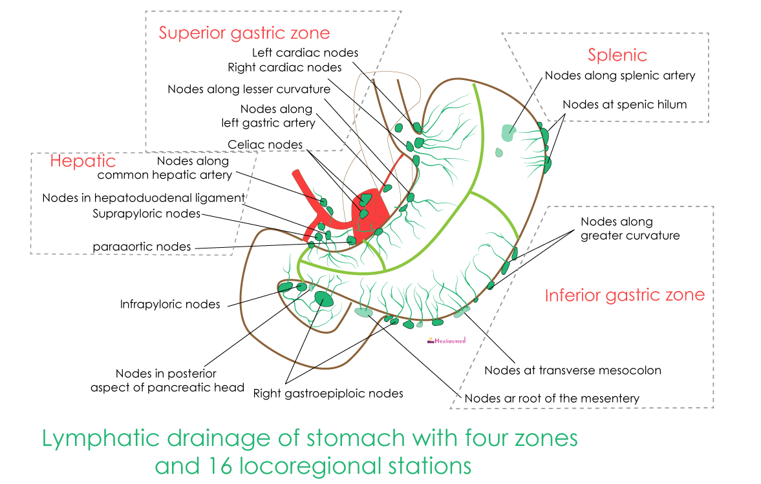


(a) The anterior view of the stomach.

